Asiqul Hoque

Homework 9

Section 1 Lesson 3: Date Functions

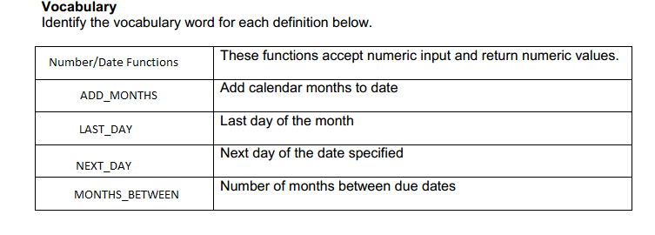

1.SELECT ROUND(MONTHS_BETWEEN(SYSDATE,event_date),0) AS Rounded Month

FROM D_EVENTS

WHERE NAME = 'Vigil wedding';



2.SELECT ROUND(MONTHS_BETWEEN('07-SEP-2014','23-JUN-2014')*30.5,0) "Days"

FROM DUAL;



3.SELECT ROUND(MONTHS_BETWEEN('31-JAN-2015','01-JAN-2015')*30.5,0) AS "Days_2"

FROM DUAL;



4.SELECT ROUND(sysdate,'MONTH') "Nearest Rounded Month",

ROUND(sysdate,'YEAR') "Nearest Rounded Year",

TRUNC(sysdate,'MONTH') "Nearest Truncated Month",

TRUNC(sysdate,'YEAR') "Nearest Truncated Year"

FROM DUAL;



5.SELECT LAST_DAY('01-JUN-2005') AS "Last Day of June"

FROM DUAL;



6. SELECT TRUNC(MONTHS_BETWEEN(SYSDATE, BIRTHDATE) /12) AS "YEARS"

FROM F_STAFFS

WHERE first_name = 'Bob';



7.SELECT ADD_MONTHS(sysdate,6) as "Appointment DATE"

FROM DUAL;



8.select last_day(sysdate)as "Deadline"

from dual;



9.select ROUND(months_between('01-JAN-16','05-MAY-2015'),0) AS "MY BIRTHDAY"

from dual;



10.SELECT NEXT_DAY('05-MAY-2015','FRIDAY')as"Next Friday"

FROM DUAL;



11. months_Between

12. last_Day

13. It is important for businesses to be able to manipulate date data because dates are very important when it comes to payment and it helps prevent inaccuracy for times that payments that need to be made.